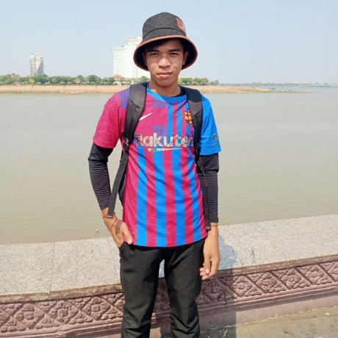

## CONTACT

PHONE

+123-456-7890

EMAIL

[hello@reallygreatsite.com](mailto:hello@reallygreatsite.com)

**WORK EXPERIENCE**

ADDRESS

123 Anywhere St. Any City

## SKILLS

* Program
* Marketing
* Team Work
* Technology
* Marketing

## LANGUAGE

* English
* French
* Spanish
* Korean

**WORK EXPERIENCE**

VOEUN CHANTHOU

DIGITAL MARKETING

energet digital marketing with5* years of experience in digital

marketing company. Skilled in data processing and

documentation analysis. At Liceria & Co. helped to increase to

increase workeffiienc by 105 by implementing a new

documentation workflow system.

* **Junior Digital Marketing**

**June 2030 – Present**

* Manager oversees company digital marketing to

more client in socail media.

* Preduct marketing
* Increated clien and customer
* **Senior Digital Marketing**

**September 2023 – Present**

* Professional class in digital marketing
* Creative idea for digital marketing
* Organizes of social media post for editorial

**Bachelor or Digital Marketing**

Bachelor of Digital Marketing Business

**ABOUT ME**